**Lab 5 *– My Calculator***

**Layout Code**

<?xml version="1.0" encoding="utf-8"?>  
<android.support.constraint.ConstraintLayout xmlns:android="http://schemas.android.com/apk/res/android"  
 xmlns:app="http://schemas.android.com/apk/res-auto"  
 xmlns:tools="http://schemas.android.com/tools"  
 android:layout_width="match_parent"  
 android:layout_height="match_parent"  
 tools:context=".MainActivity">  
  
 <Button  
 android:id="@+id/btnDot"  
 android:layout_width="wrap_content"  
 android:layout_height="wrap_content"  
 android:layout_marginTop="20dp"  
 android:text="@string/btnDot"  
 android:textSize="24sp"  
 android:textStyle="bold"  
 app:layout_constraintEnd_toStartOf="@+id/btn0"  
 app:layout_constraintHorizontal_bias="0.5"  
 app:layout_constraintStart_toStartOf="parent"  
 app:layout_constraintTop_toBottomOf="@+id/btn7" />  
  
 <Button  
 android:id="@+id/btnEql"  
 android:layout_width="wrap_content"  
 android:layout_height="wrap_content"  
 android:layout_marginTop="20dp"  
 android:text="@string/btnEql"  
 android:textSize="24sp"  
 android:textStyle="bold"  
 app:layout_constraintEnd_toStartOf="@+id/btnDiv"  
 app:layout_constraintHorizontal_bias="0.5"  
 app:layout_constraintStart_toEndOf="@+id/btn0"  
 app:layout_constraintTop_toBottomOf="@+id/btn9" />  
  
 <Button  
 android:id="@+id/btnDiv"  
 android:layout_width="wrap_content"  
 android:layout_height="wrap_content"  
 android:layout_marginTop="20dp"  
 android:text="@string/btnDiv"  
 android:textSize="24sp"  
 android:textStyle="bold"  
 app:layout_constraintEnd_toEndOf="parent"  
 app:layout_constraintHorizontal_bias="0.5"  
 app:layout_constraintStart_toEndOf="@+id/btnEql"  
 app:layout_constraintTop_toBottomOf="@+id/btnMul" />  
  
 <Button  
 android:id="@+id/btn0"  
 android:layout_width="wrap_content"  
 android:layout_height="wrap_content"  
 android:layout_marginTop="20dp"  
 android:text="@string/btn0"  
 android:textSize="24sp"  
 android:textStyle="bold"  
 app:layout_constraintEnd_toStartOf="@+id/btnEql"  
 app:layout_constraintHorizontal_bias="0.5"  
 app:layout_constraintStart_toEndOf="@+id/btnDot"  
 app:layout_constraintTop_toBottomOf="@+id/btn8" />  
  
 <Button  
 android:id="@+id/btn7"  
 android:layout_width="wrap_content"  
 android:layout_height="wrap_content"  
 android:layout_marginTop="20dp"  
 android:text="@string/btn7"  
 android:textSize="24sp"  
 android:textStyle="bold"  
 app:layout_constraintEnd_toStartOf="@+id/btn8"  
 app:layout_constraintHorizontal_bias="0.5"  
 app:layout_constraintStart_toStartOf="parent"  
 app:layout_constraintTop_toBottomOf="@+id/btn4" />  
  
 <Button  
 android:id="@+id/btn9"  
 android:layout_width="wrap_content"  
 android:layout_height="wrap_content"  
 android:layout_marginTop="20dp"  
 android:text="@string/btn9"  
 android:textSize="24sp"  
 android:textStyle="bold"  
 app:layout_constraintEnd_toStartOf="@+id/btnMul"  
 app:layout_constraintHorizontal_bias="0.5"  
 app:layout_constraintStart_toEndOf="@+id/btn8"  
 app:layout_constraintTop_toBottomOf="@+id/btn6" />  
  
 <Button  
 android:id="@+id/btnMul"  
 android:layout_width="wrap_content"  
 android:layout_height="wrap_content"  
 android:layout_marginTop="20dp"  
 android:text="@string/btnMul"  
 android:textSize="24sp"  
 android:textStyle="bold"  
 app:layout_constraintEnd_toEndOf="parent"  
 app:layout_constraintHorizontal_bias="0.5"  
 app:layout_constraintStart_toEndOf="@+id/btn9"  
 app:layout_constraintTop_toBottomOf="@+id/btnSub" />  
  
 <Button  
 android:id="@+id/btn8"  
 android:layout_width="wrap_content"  
 android:layout_height="wrap_content"  
 android:layout_marginTop="20dp"  
 android:text="@string/btn8"  
 android:textSize="24sp"  
 android:textStyle="bold"  
 app:layout_constraintEnd_toStartOf="@+id/btn9"  
 app:layout_constraintHorizontal_bias="0.5"  
 app:layout_constraintStart_toEndOf="@+id/btn7"  
 app:layout_constraintTop_toBottomOf="@+id/btn5" />  
  
 <Button  
 android:id="@+id/btn4"  
 android:layout_width="wrap_content"  
 android:layout_height="wrap_content"  
 android:layout_marginTop="20dp"  
 android:text="@string/btn4"  
 android:textSize="24sp"  
 android:textStyle="bold"  
 app:layout_constraintEnd_toStartOf="@+id/btn5"  
 app:layout_constraintHorizontal_bias="0.5"  
 app:layout_constraintStart_toStartOf="parent"  
 app:layout_constraintTop_toBottomOf="@+id/btn1" />  
  
 <Button  
 android:id="@+id/btn6"  
 android:layout_width="wrap_content"  
 android:layout_height="wrap_content"  
 android:layout_marginTop="20dp"  
 android:text="@string/btn6"  
 android:textSize="24sp"  
 android:textStyle="bold"  
 app:layout_constraintEnd_toStartOf="@+id/btnSub"  
 app:layout_constraintHorizontal_bias="0.5"  
 app:layout_constraintStart_toEndOf="@+id/btn5"  
 app:layout_constraintTop_toBottomOf="@+id/btn3" />  
  
 <Button  
 android:id="@+id/btnSub"  
 android:layout_width="wrap_content"  
 android:layout_height="wrap_content"  
 android:layout_marginTop="20dp"  
 android:text="@string/btnSub"  
 android:textSize="24sp"  
 android:textStyle="bold"  
 app:layout_constraintEnd_toEndOf="parent"  
 app:layout_constraintHorizontal_bias="0.5"  
 app:layout_constraintStart_toEndOf="@+id/btn6"  
 app:layout_constraintTop_toBottomOf="@+id/btnAdd" />  
  
 <Button  
 android:id="@+id/btn5"  
 android:layout_width="wrap_content"  
 android:layout_height="wrap_content"  
 android:layout_marginTop="20dp"  
 android:text="@string/btn5"  
 android:textSize="24sp"  
 android:textStyle="bold"  
 app:layout_constraintEnd_toStartOf="@+id/btn6"  
 app:layout_constraintHorizontal_bias="0.5"  
 app:layout_constraintStart_toEndOf="@+id/btn4"  
 app:layout_constraintTop_toBottomOf="@+id/btn2" />  
  
 <EditText  
 android:id="@+id/panelText"  
 android:layout_width="350dp"  
 android:layout_height="85dp"  
 android:layout_marginTop="80dp"  
 android:autofillHints=""  
 android:background="@color/white"  
 android:cursorVisible="true"  
 android:ems="10"  
 android:hint="@string/enter_here"  
 android:inputType="textPersonName"  
 android:singleLine="false"  
 android:textAllCaps="false"  
 android:textAppearance="@style/TextAppearance.AppCompat.Large"  
 android:textSize="30sp"  
 android:textStyle="bold"  
 app:layout_constraintEnd_toEndOf="parent"  
 app:layout_constraintHorizontal_bias="0.495"  
 app:layout_constraintStart_toStartOf="parent"  
 app:layout_constraintTop_toTopOf="parent" />  
  
 <Button  
 android:id="@+id/btn3"  
 android:layout_width="wrap_content"  
 android:layout_height="wrap_content"  
 android:layout_marginTop="68dp"  
 android:text="@string/btn3"  
 android:textSize="24sp"  
 android:textStyle="bold"  
 app:layout_constraintEnd_toStartOf="@+id/btnAdd"  
 app:layout_constraintHorizontal_bias="0.5"  
 app:layout_constraintStart_toEndOf="@+id/btn2"  
 app:layout_constraintTop_toBottomOf="@+id/panelText" />  
  
 <Button  
 android:id="@+id/btn1"  
 android:layout_width="wrap_content"  
 android:layout_height="wrap_content"  
 android:layout_marginTop="68dp"  
 android:text="@string/btn1"  
 android:textSize="24sp"  
 android:textStyle="bold"  
 app:layout_constraintEnd_toStartOf="@+id/btn2"  
 app:layout_constraintHorizontal_bias="0.5"  
 app:layout_constraintStart_toStartOf="parent"  
 app:layout_constraintTop_toBottomOf="@+id/panelText" />  
  
 <Button  
 android:id="@+id/btnAdd"  
 android:layout_width="wrap_content"  
 android:layout_height="wrap_content"  
 android:layout_marginTop="68dp"  
 android:text="@string/btnAdd"  
 android:textSize="24sp"  
 android:textStyle="bold"  
 app:layout_constraintEnd_toEndOf="parent"  
 app:layout_constraintHorizontal_bias="0.5"  
 app:layout_constraintStart_toEndOf="@+id/btn3"  
 app:layout_constraintTop_toBottomOf="@+id/panelText" />  
  
 <Button  
 android:id="@+id/btn2"  
 android:layout_width="wrap_content"  
 android:layout_height="wrap_content"  
 android:layout_marginTop="68dp"  
 android:text="@string/btn2"  
 android:textSize="24sp"  
 android:textStyle="bold"  
 app:layout_constraintEnd_toStartOf="@+id/btn3"  
 app:layout_constraintHorizontal_bias="0.5"  
 app:layout_constraintStart_toEndOf="@+id/btn1"  
 app:layout_constraintTop_toBottomOf="@+id/panelText" />  
  
 <Button  
 android:id="@+id/btnClr"  
 android:layout_width="wrap_content"  
 android:layout_height="wrap_content"  
 android:layout_marginTop="8dp"  
 android:layout_marginBottom="32dp"  
 android:text="@string/btnClr"  
 android:textSize="18sp"  
 android:textStyle="bold"  
 app:layout_constraintBottom_toBottomOf="parent"  
 app:layout_constraintEnd_toEndOf="parent"  
 app:layout_constraintHorizontal_bias="0.498"  
 app:layout_constraintStart_toStartOf="parent"  
 app:layout_constraintTop_toBottomOf="@+id/btnEql"  
 app:layout_constraintVertical_bias="0.172" />  
  
</android.support.constraint.ConstraintLayout>

**JAVA Code**

package com.example.mycalculator;  
  
import android.support.v7.app.AppCompatActivity;  
import android.os.Bundle;  
import android.view.View;  
import android.widget.Button;  
import android.widget.EditText;  
  
public class MainActivity extends AppCompatActivity {  
  
 Button btn1,btn2,btn3,btn4,btn5,btn6,btn7,btn8,btn9,btn0,btnAdd,btnSub,btnMul,btnDiv,btnDot,btnEql,btnClr;  
 EditText panel;  
 float res1,res2;  
 boolean Add,Sub,Mul,Div;  
  
 @Override  
 protected void onCreate(Bundle savedInstanceState) {  
 super.onCreate(savedInstanceState);  
 setContentView(R.layout.*activity_main*);  
  
 btn0 = (Button)findViewById(R.id.*btn0*);  
 btn1 = (Button)findViewById(R.id.*btn1*);  
 btn2 = (Button)findViewById(R.id.*btn2*);  
 btn3 = (Button)findViewById(R.id.*btn3*);  
 btn4 = (Button)findViewById(R.id.*btn4*);  
 btn5 = (Button)findViewById(R.id.*btn5*);  
 btn6 = (Button)findViewById(R.id.*btn6*);  
 btn7 = (Button)findViewById(R.id.*btn7*);  
 btn8 = (Button)findViewById(R.id.*btn8*);  
 btn9 = (Button)findViewById(R.id.*btn9*);  
 btnAdd = (Button)findViewById(R.id.*btnAdd*);  
 btnSub = (Button)findViewById(R.id.*btnSub*);  
 btnMul = (Button)findViewById(R.id.*btnMul*);  
 btnDiv = (Button)findViewById(R.id.*btnDiv*);  
 btnDot = (Button)findViewById(R.id.*btnDot*);  
 btnEql = (Button)findViewById(R.id.*btnEql*);  
 btnClr = (Button)findViewById(R.id.*btnClr*);  
 panel = (EditText)findViewById(R.id.*panelText*);  
  
 btn0.setOnClickListener(new View.OnClickListener(){  
 @Override  
 public void onClick(View v) {  
 panel.setText(panel.getText() + "0");  
 }  
 });  
  
 btn1.setOnClickListener(new View.OnClickListener(){  
 @Override  
 public void onClick(View v) {  
 panel.setText(panel.getText() + "1");  
 }  
 });  
  
 btn2.setOnClickListener(new View.OnClickListener(){  
 @Override  
 public void onClick(View v) {  
 panel.setText(panel.getText()+"2");  
 }  
 });  
  
 btn3.setOnClickListener(new View.OnClickListener(){  
 @Override  
 public void onClick(View v) {  
 panel.setText(panel.getText() + "3");  
 }  
 });  
  
 btn4.setOnClickListener(new View.OnClickListener(){  
 @Override  
 public void onClick(View v) {  
 panel.setText(panel.getText() + "4");  
 }  
 });  
  
 btn5.setOnClickListener(new View.OnClickListener(){  
 @Override  
 public void onClick(View v) {  
 panel.setText(panel.getText() + "5");  
 }  
 });  
  
 btn6.setOnClickListener(new View.OnClickListener(){  
 @Override  
 public void onClick(View v) {  
 panel.setText(panel.getText() + "6");  
 }  
 });  
  
 btn7.setOnClickListener(new View.OnClickListener(){  
 @Override  
 public void onClick(View v) {  
 panel.setText(panel.getText() + "7");  
 }  
 });  
  
 btn8.setOnClickListener(new View.OnClickListener(){  
 @Override  
 public void onClick(View v) {  
 panel.setText(panel.getText() + "8");  
 }  
 });  
  
 btn9.setOnClickListener(new View.OnClickListener(){  
 @Override  
 public void onClick(View v) {  
 panel.setText(panel.getText() + "9");  
 }  
 });  
  
 btnDot.setOnClickListener(new View.OnClickListener(){  
 @Override  
 public void onClick(View v) {  
 panel.setText(panel.getText() + ".");  
 }  
 });  
  
 btnAdd.setOnClickListener(new View.OnClickListener(){  
 @Override  
 public void onClick(View v) {  
 if(panel==null)  
 {  
 panel.setText("");  
 }  
 else  
 {  
 res1 = Float.*parseFloat*(panel.getText()+"");  
 Add = true;  
 panel.setText(null);  
 }  
 }  
 });  
  
 btnSub.setOnClickListener(new View.OnClickListener(){  
 @Override  
 public void onClick(View v) {  
 if(panel==null)  
 {  
 panel.setText("");  
 }  
 else  
 {  
 res1 = Float.*parseFloat*(panel.getText()+"");  
 Sub = true;  
 panel.setText(null);  
 }  
 }  
 });  
  
 btnMul.setOnClickListener(new View.OnClickListener(){  
 @Override  
 public void onClick(View v) {  
 if(panel==null)  
 {  
 panel.setText("");  
 }  
 else  
 {  
 res1 = Float.*parseFloat*(panel.getText()+"");  
 Mul = true;  
 panel.setText(null);  
 }  
 }  
 });  
  
 btnDiv.setOnClickListener(new View.OnClickListener(){  
 @Override  
 public void onClick(View v) {  
 if(panel==null)  
 {  
 panel.setText("");  
 }  
 else  
 {  
 res1 = Float.*parseFloat*(panel.getText()+"");  
 Div = true;  
 panel.setText(null);  
 }  
 }  
 });  
  
 btnEql.setOnClickListener(new View.OnClickListener(){  
 @Override  
 public void onClick(View v) {  
 res2 = Float.*parseFloat*(String.*valueOf*(panel.getText()));  
  
 if(Add)  
 {  
 panel.setText((res1+res2)+"");  
 Add = false;  
 }  
 if(Sub)  
 {  
 panel.setText((res1-res2)+"");  
 Sub = false;  
 }  
 if(Mul)  
 {  
 panel.setText((res1*res2)+"");  
 Mul = false;  
 }  
 if(Div)  
 {  
 panel.setText((res1/res2)+"");  
 Div = false;  
 }  
 }  
 });  
  
 btnClr.setOnClickListener(new View.OnClickListener(){  
 @Override  
 public void onClick(View v) {  
 panel.setText("");  
 }  
 });  
 }  
}

**Manifest File**

<?xml version="1.0" encoding="utf-8"?>  
<manifest xmlns:android="http://schemas.android.com/apk/res/android"  
 package="com.example.mycalculator">  
  
 <application  
 android:allowBackup="true"  
 android:icon="@mipmap/ic_launcher"  
 android:label="@string/app_name"  
 android:roundIcon="@mipmap/ic_launcher_round"  
 android:supportsRtl="true"  
 android:theme="@style/Theme.MyCalculator">  
 <activity android:name=".MainActivity">  
 <intent-filter>  
 <action android:name="android.intent.action.MAIN" />  
  
 <category android:name="android.intent.category.LAUNCHER" />  
 </intent-filter>  
 </activity>  
 </application>  
  
</manifest>

**Output Screenshots**

1. **Initial Screen**

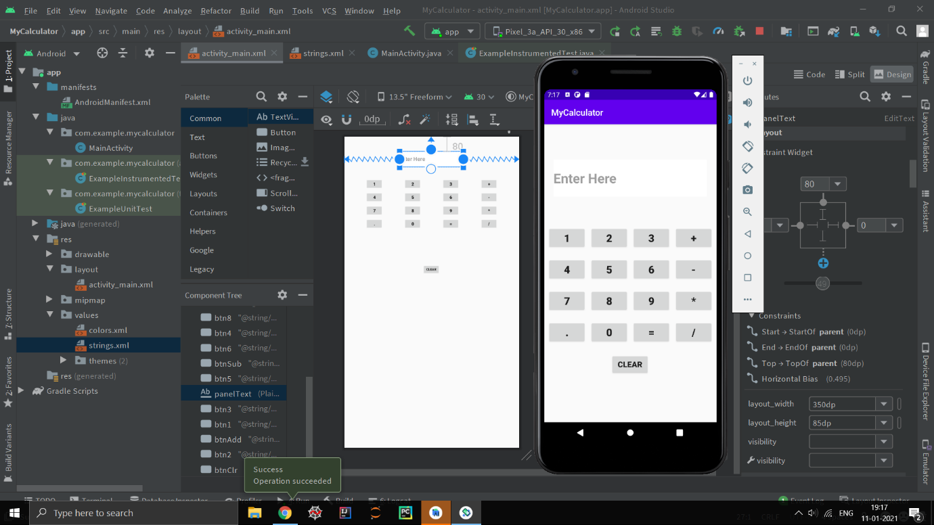

1. **Putting Expression**

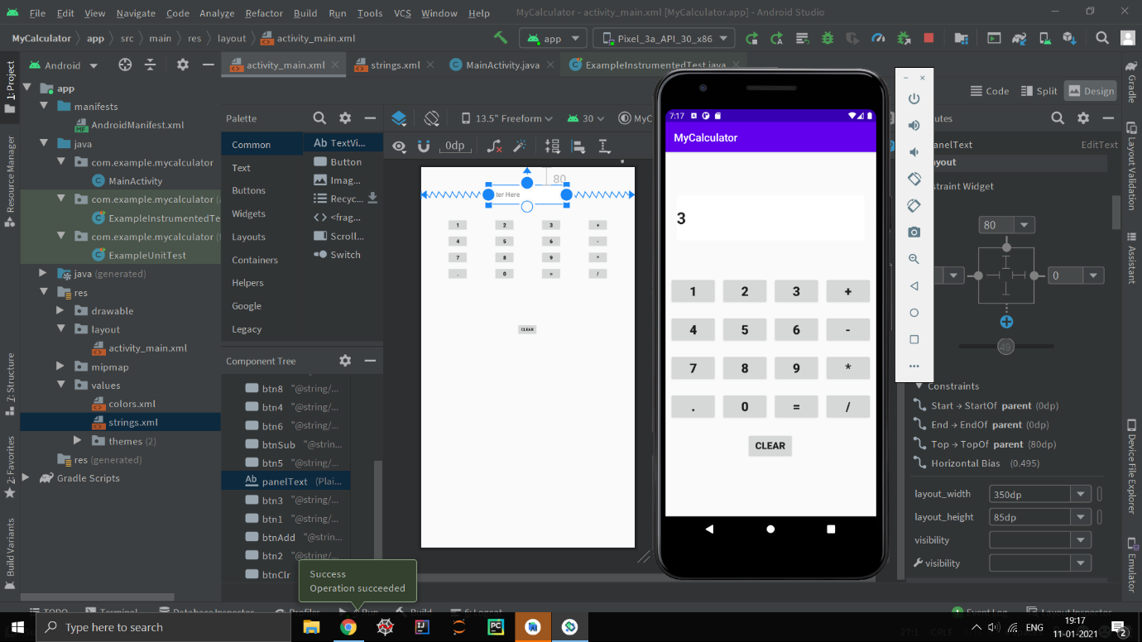

1. **Result**

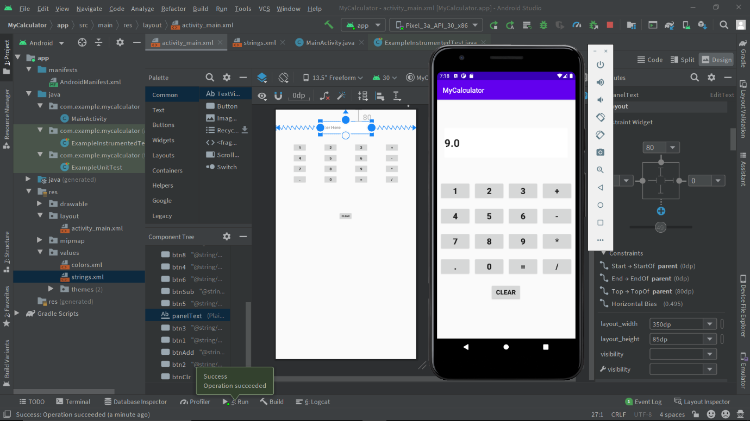

1. **Clicking Clear Button.**

